**Maris Stella College (Autonomous), Vijayawada**

**Profile of M. Blessy Olive**

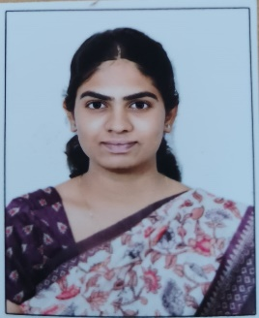

Name: M. Blessy Olive

Educational Qualification: M. Sc. In Genetics and Plant Breeding

Designation: Assistant Professor

Department: Agriculture and Rural Development

Years of experience in Maris Stella college: 9 months

G Suite Email Id: blessyolive369@gmail.com

Email Id: blessyolive369@gmail.com

Contact No: 9490559714

Languages Known: English, Telugu, Hindi, Marathi

Areas of Interest: Genetics and Plant Breeding, Biotechnology

**Academic Contribution:**

Assistant Professor : 2023 to Till Date

**Academic Profile:**

**Refresher Courses/Orientation Courses/Short Term Courses Attended:**

1. Orientation Programme for the New Joining Faculty in Maris Stella College.

**RESEARCH WORK:**

1.Component approach of Quantitative Characters in Finger Millet *Eleusine coracana* L.,

**Journals**

1. **K Monika Evangelin, Ajay Pal Yadav, Blessy Olive and Dr. G Lavanya. Inter-relationship and path coefficient analysis among quantitative traits in Indian mustard (Brassica juncea L. Czern and Cos). J Pharmacogn Phytochem 2023;12(1):562-565.**

**Conferences**

**International:**

1.Attended 3rd International Conference regarding Global Initiatives in Agricultural, Forestry and Applied Sciences. (GIAFAS-2021)

**Webinars/FDP’s:**

**1. M. Blessy Olive**, Assistant Professor, Dept. of Agriculture and Rural Development participate, Participated in BoS meeting in the Dpt. Of Agriculture and Rural Development,Maris Stella College, Vijayawada.

**2. M. Blessy Olive**, Assistant Professor, Dept. of Agriculture and Rural Development organised and Celebration: **“International Year of Millets 2023   (IYOM2023),** Date On :18.03.2023.

**Resource Person**

1. Internal examiner for Semester End Examination RAWE Programme (7th Semester) , KVK Jammikunta, Karimnagar on 14-11-2023.
2. E.Tv Telangana and Andhra Pradesh: (Yuva Programme) Talk about the Field and Polyhouse Management and Advantages of Plant Breeding.

**Other Activities:**

1.I create useful content in social media.

2. I am passionate about Teaching Profession.